Project Design Phase-II
Data Flow Diagram & User Stories

Date | 30 September 2026
Team ID
Project Name | Script-Controlled ACL – Restrict Record Access Based on Field Value
Maximum Marks | 4 Marks

Data Flow Diagrams:
A Data Flow Diagram (DFD) is a traditional visual representation of the information flows within a system. A neat and clear DFD can depict the right amount of the system requirement graphically. It shows how data enters and leaves the system, what changes the information, and where data is stored.
Level 0 (context diagram)
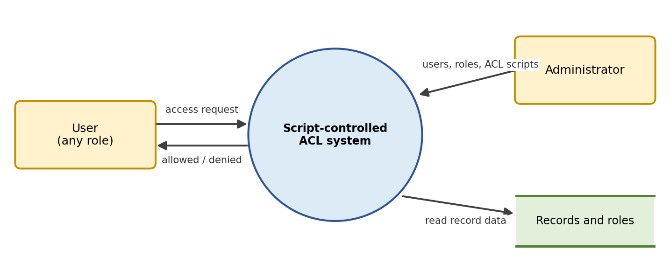
Level 1 (script-controlled ACL flow)
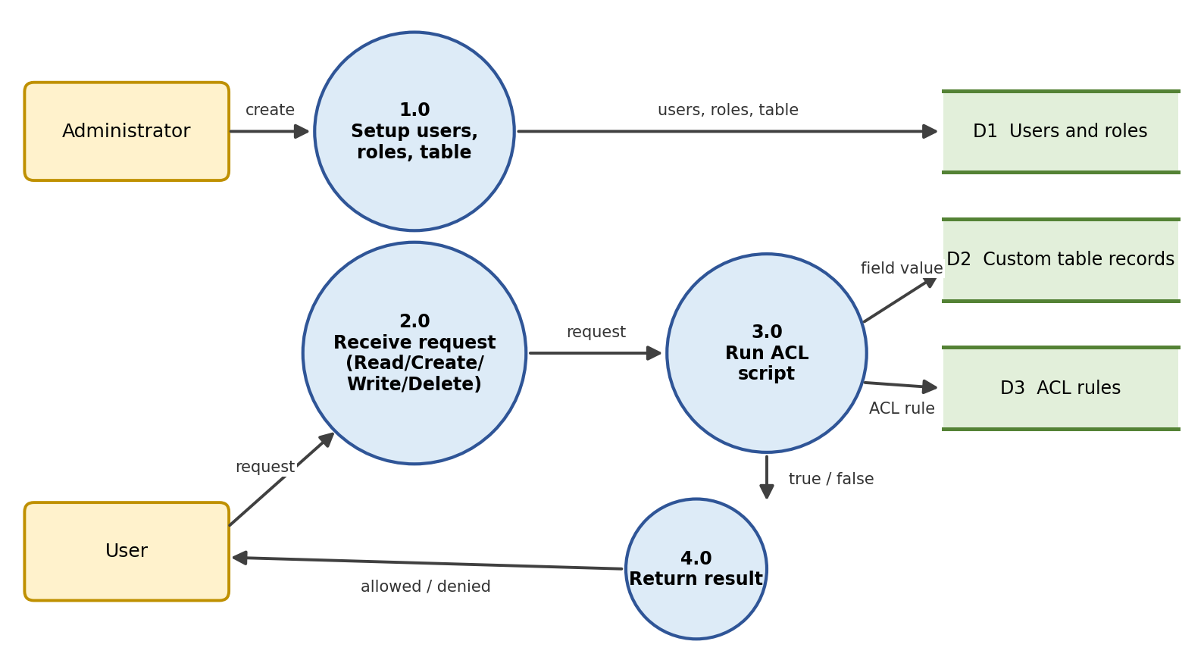

User Stories
Use the below template to list all the user stories for the product.
User Type | Functional Requirement (Epic) | User Story Number | User Story / Task | Acceptance criteria | Priority | Release
Administrator | User and Role Management | USN-1 | As an administrator, I can create users so that each team member can be tested against the ACLs. | Users are listed in the user table and can be impersonated | High | Sprint-1
Administrator | User and Role Management | USN-2 | As an administrator, I can create roles and assign them to users. | Each role is shown on the user's record | High | Sprint-1
Administrator | Table Creation | USN-3 | As an administrator, I can create a custom table with a field that decides who may access each record. | Table and field exist and records can be saved | High | Sprint-1
Administrator | ACL – Read | USN-4 | As an administrator, I can create a Read ACL with a script that checks the field value, so users see only permitted records. | Authorised user sees matching records; restricted user sees none | High | Sprint-2
Administrator | ACL – Create | USN-5 | As an administrator, I can create a Create ACL with a script, so only permitted users can add records. | Authorised user can create a record; others are blocked | High | Sprint-2
Administrator | ACL – Write | USN-6 | As an administrator, I can create a Write ACL with a script, so only permitted users can edit records. | Authorised user can edit a record; others are blocked | High | Sprint-2
Administrator | ACL – Delete | USN-7 | As an administrator, I can create a Delete ACL with a script, so only permitted users can delete records. | Authorised user can delete a record; others are blocked | Medium | Sprint-3
Authorised User | Record Access | USN-8 | As an authorised user, I can view, create and edit records whose field value matches my access. | I can work with matching records without errors | High | Sprint-2
Restricted User | Record Access | USN-9 | As a restricted user, I cannot open, edit or delete records outside my access. | Other records are hidden or the action is denied | High | Sprint-2
Tester / Team Lead | Verification and Outcome | USN-10 | As a tester, I can impersonate each user and confirm that Read, Create, Write and Delete behave as expected. | Result recorded for every role and operation | Medium | Sprint-3

